Handout 2: Blooms’ Taxonomy

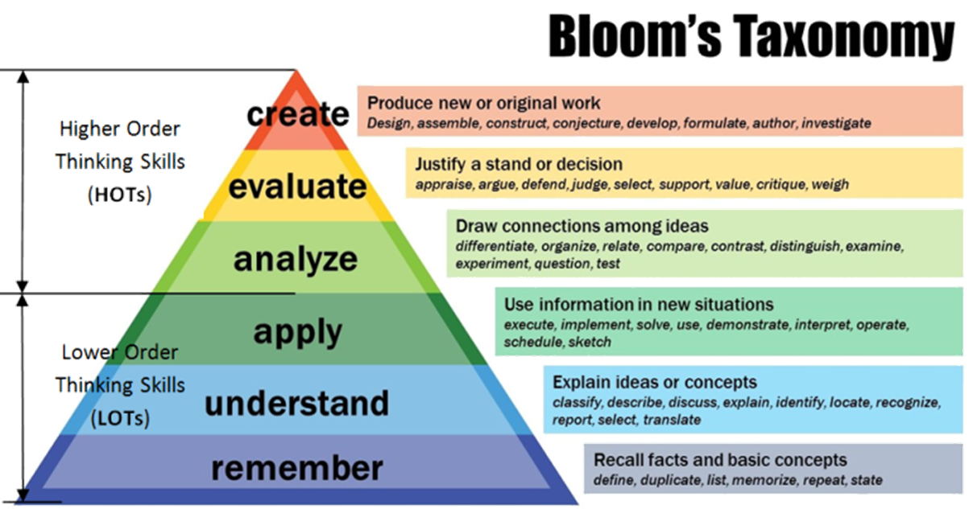
WHAT IS BLOOM’S TAXONOMY?
Bloom’s Taxonomy is a framework for identifying and organizing what educators want students to learn from a given instructional activity. It was originally conceived to create common learning objectives across courses and departments and provide educators with standardized language to use when framing learning goals for curricula and comprehensive examinations. Now, Bloom’s taxonomy can be used as a potential model for framing educational objectives within a course and as a guide to structuring activities and assessments based on learning goals.
WHY IS BLOOM’S TAXONOMY IMPORTANT?
Bloom’s Taxonomy is useful for framing writing instruction in college courses as it helps instructors and TAs create assignments that will enhance students’ understanding of important concepts and ideas and enable them to meet the key course objectives.
HOW BLOOM’S CAN AID IN COURSE DESIGN
Bloom’s taxonomy is a powerful tool to help develop learning objectives because it explains the process of learning:
- Before you can understand a concept, you must remember it.
- To apply a concept you must first understand it.
- In order to evaluate a process, you must have analyzed it.
- To create an accurate conclusion, you must have completed a thorough evaluation.
WHAT ARE BLOOM’S TAXONOMY VERBS
Bloom’s Taxonomy Verbs are used to write measurable learning objectives and learning activities. This list of useful verbs for creating learning outcomes is arranged according to Bloom’s Taxonomy of Educational Objectives, which identifies different cognitive domains associated with levels of learning.
ACTION VERBS FOR DEVELOPING LEARNING OUTCOMES
Competence | Skills Demonstrated | Action Verbs | Examples
Remembering  (Level 1) | - observe and recall of information  - knowledge of dates, events, places  - knowledge of major ideas  - knowledge of major processes or procedures  - mastery of subject matter | arrange, cite, collect, define, describe, duplicate, enumerate, examine, find, identify, indicate, label, list, locate, match, memorize, name, order, outline, quote, recall, recite, recognize, record, relate, repeat, reproduce, retrieve, select, show, state, tabulate. | - list the first ten alkanes  - state the steps in the procedure for calibrating a gas chromatograph.
Understanding  (Level 2) | - understand information  - grasp meaning  - translate knowledge into new context  - interpret facts, compare, contrast  - order, group, infer causes  - predict consequences | arrange, articulate, associate, classify, compare, contrast, describe, differentiate, discuss, distinguish, exemplify, expand, explain, express, extend, identify, illustrate, indicate, interpret, locate, match, outline, paraphrase, recognize, relate, report, restate, review, select, summarise. | - explain in your own words the concept of vapor pressure.  - interpret the output from an ASPEN flowsheet simulation
Applying  (Level 3) | - use information  - use methods, concepts, theories in new situations  - solve problems using required skills or knowledge  - use equipment, tools | Administer, apply, calculate, chart, classify, collect, compute, control, convert, demonstrate, determine, develop, dramatize, draw, employ, estimate, execute, exhibit, illustrate, implement, manipulate, model, modify, operate, practice, prepare, relate, report, select, show, sketch, transfer, use, utilize. | - calculate the probability that two sample means will differ by more than 5%  - solve the compressibility factor equation of state for P, T, or V from given values of the other two.
Analyzing  (Level 4) | - see patterns  - organize of parts  - recognize of hidden meanings  - identify components  - simplify complex information;  - metacognition | analyze, calculate, categorize, classify, compare, contrast, correlate, deconstruct, detect, differentiate, discriminate, distinguish, examine, explain, interpret, organize, quantify, research, scrutinize, separate, sequence, subdivide, survey, test, translate | - Compare the sales process followed in the USA with that of China.  - explain why we feel warm in 70 F air and cold in 70 F water.
Evaluating  (Level 5) | - use old ideas to create new ones  - compare and discriminate between ideas  - relate knowledge from several areas  - predict, draw conclusions  - think critically  - assess the value of theories, presentations  - make choices based on reasoned argument  - verify or question the value of the evidence  - recognize subjectivity | appraise, argue, assess, categorize, choose, compare, conclude, contrast, critique, debate, decide, deduce, defend, discriminate, dispute, establish, estimate, evaluate, gauge, generalize, hypothesize, infer, interpret, judge, justify, measure, monitor, negotiate, predict, prioritize, propose, prove, rank, rate, recommend, relate, select, solve, support, validate, verify | - determine which of the given heat exchanger configurations is better, and explain your reasoning  - select from among available options for expanding production capacity, and justify your choice  - critique an essay, report, or article for accuracy and style.
Creating  (Level 6) | - combine ideas to develop an original idea or product  - engage in creative thinking. | adapt, anticipate, assemble, change, communicate, compare, compile, compose, construct, create, derive, design, develop, devise, formulate, generate, hypothesize, improve, incorporate, infer, initiate, integrate, interpret, invent, make, modify, originate, plan, produce, reconstruct, revise, synthesize, transform, visualize | - formulate a model-based alternative to the PID controller design presented in Wednesday’s lecture  - make up a homework problem involving material we covered in class this week;  - design a brochure.

